NBL Preservation Group

Honorary President Professor Dugald Cameron OBE

Aug 2021 Newsletter

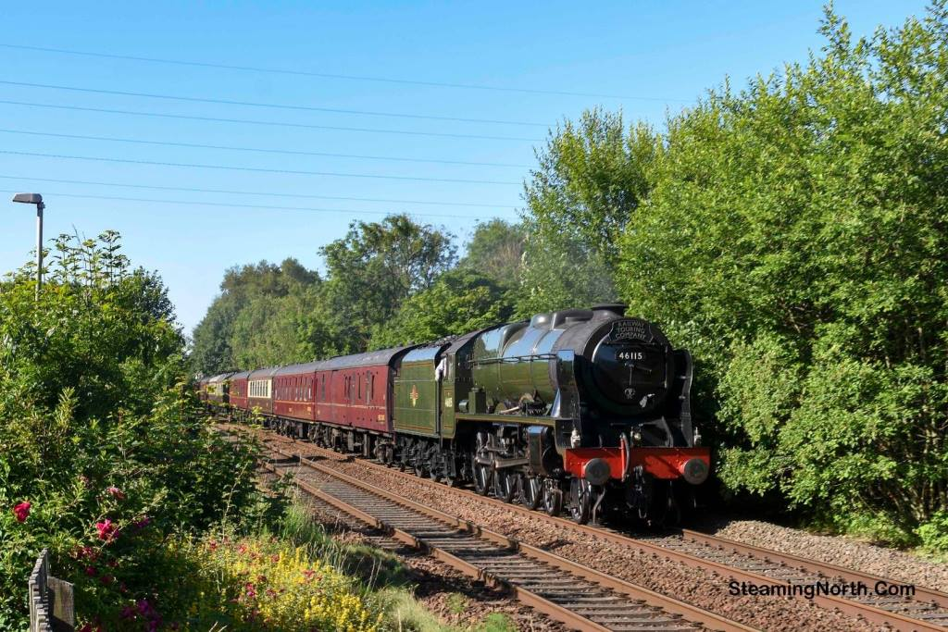

SUMMER SEASON ON S&C (photo John Robinson)

Stanier ‘Royal Scot’ No 46115 ‘Scots Guardsman’ (NB 23610) coasts into Ramsgreave and Wilpshire station on the Ribble Valley Line on 17th July 2021 with the Cumbrian Mountain Express heading for Hellifield and Carlisle. With the train originating deep in LMS territory at Crewe, No 46115 was very much on home ground
having been built by NBL for the London Midland & Scottish Railway in 1927, and quite incredibly it will be celebrating its’ centenary in a few years time !

The ‘Cumbrian Mountain Express’ is one of a good number of specials that have travelled over the famous Settle & Carlisle route so far this summer. The line is the route of choice for several railtour promoters so steam has been seen there two or three times each week since restrictions were eased at the start of July. Enthusiasts have been treated to the sight of more than one special on the line on several days and on at least one occasion the wonderful sight of steam crossing steam at speed in opposite directions !

Steam locomotives to have tackled this testing route in the last few months have included 35018 ‘British India Line’, 45690 Leander, 45699 Galatea, 46100 ‘Royal Scot, 46115 Scots Guardsman, 46201 Princess Elizabeth, 60103 Flying Scotsman and 60163 Tornado - and there are still more trains to come ! More wonderful photos of steam on the very scenic Settle & Carlisle line can be found on the S&C Facebook Page at : https://www.facebook.com/groups/1460936464144762
(2)
BAHAMAS HEADS SOUTH (photos John Robinson & John Hillier)

For the first time since it was taken out of service by British Railways in the 1960’s, the ex LMS ‘Jubilee’ Class 4-6-0 No 45596 ‘Bahamas’ (NB 24154) made a welcome return to the London area during July and August to work a series of railtours.

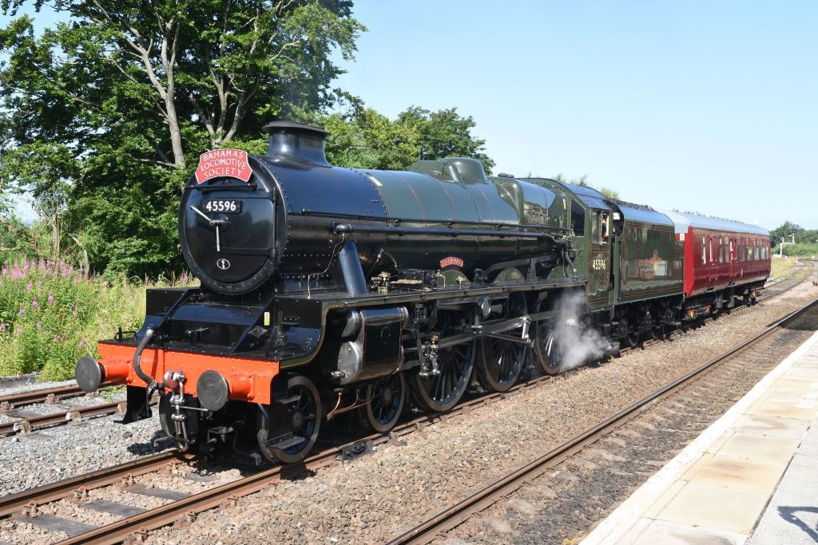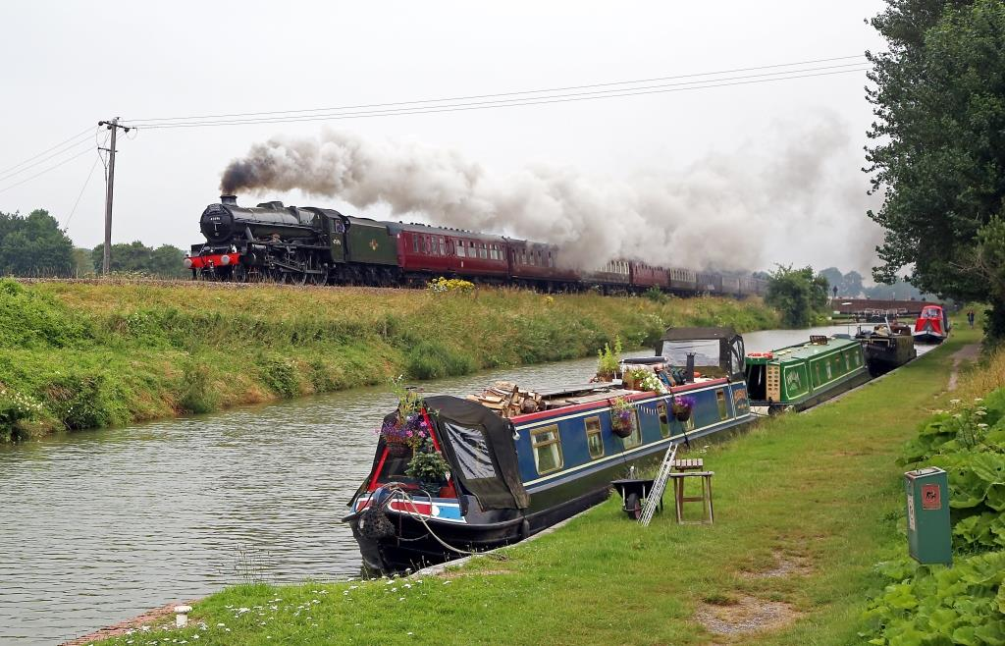
The immaculate loco is seen above on 16th July during a pause at Hellifield on its’ way south from Keighley to London on and on 24th July at the classic location near Crofton alongside the Kennett & Avon Canal on a special to the West Somerset Railway. The lower photos show No 45596 at the water stop at Winchfield on 5th August en route to Weymouth and a happy group including His Excellency Ellison E. Greenslade QPM the Bahamas High Commissioner, David & Patricia Buck and Keith Whitmore, Chairman of the BLS, at London Paddington prior to a trip to Salisbury and back on 18th July.

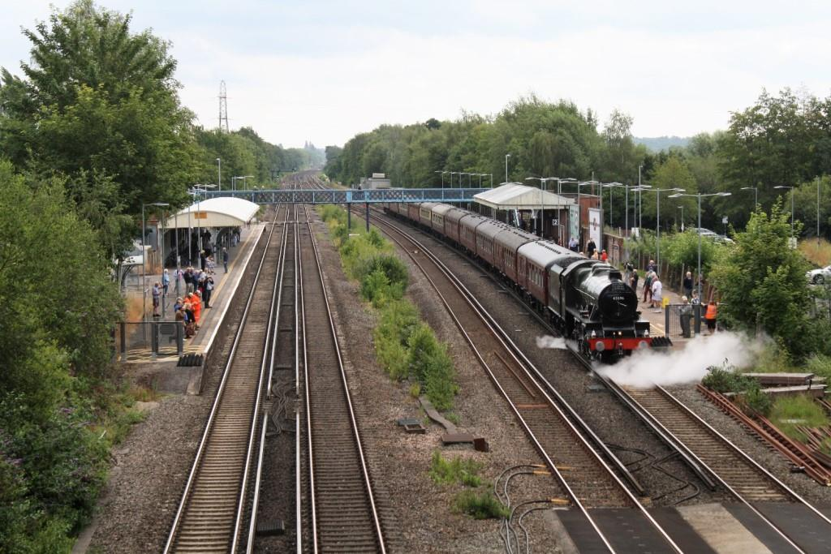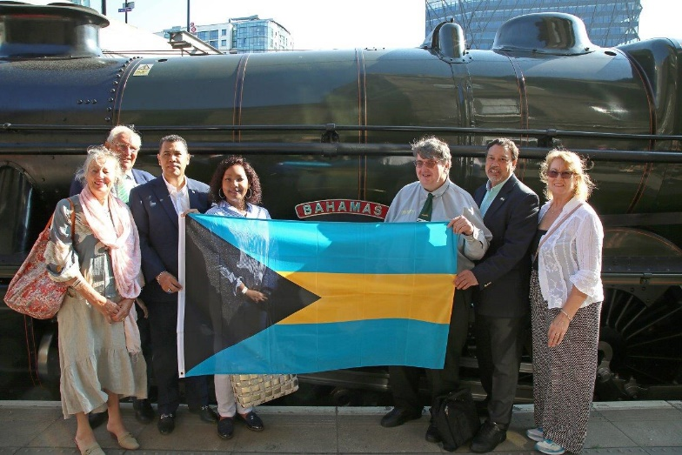
The relationship between the Bahamas Locomotive Society and the Bahamas Tourist Office, and in particular the High Commissioner, began in 1967, when they received a £25 donation towards 45596’s preservation. They maintained regular contact with the Office over several years and there was representation at 45596’s first steaming at Tyseley after its recent overhaul and again at its re Commissioning at Ingrow.
The engines’ first visit to London was commemorated with a trip from Paddington to Salisbury and back on 18 July 2021 and was the first occasion that the High Commissioner had travelled behind the loco. He and his small party were guests of David Buck from Steam Dreams, something which the BLS had facilitated.
The BLS used the occasion to present The High Commissioner with one of the mounted replica nameplates from the 1967/73 period which carried the crest of the Islands – ironically the crest of the Islands has subsequently been changed !

Full details 45596 and the BLS can be found on : https://www.bahamaslocomotivesociety.com

(3)
WITBANK CONSOLIDATED (photos : Richard Manton)
Situated in the Witbank Coalfield, around 70 miles East of Pretoria, Witbank Consolidated Colliery operated a small but very interesting fleet of steam locomotives. During our correspondent Richard Manton’s visits to the mine, he photographed three of them on shunting duties and coal haulage to the SAR yard at Saaiwater.

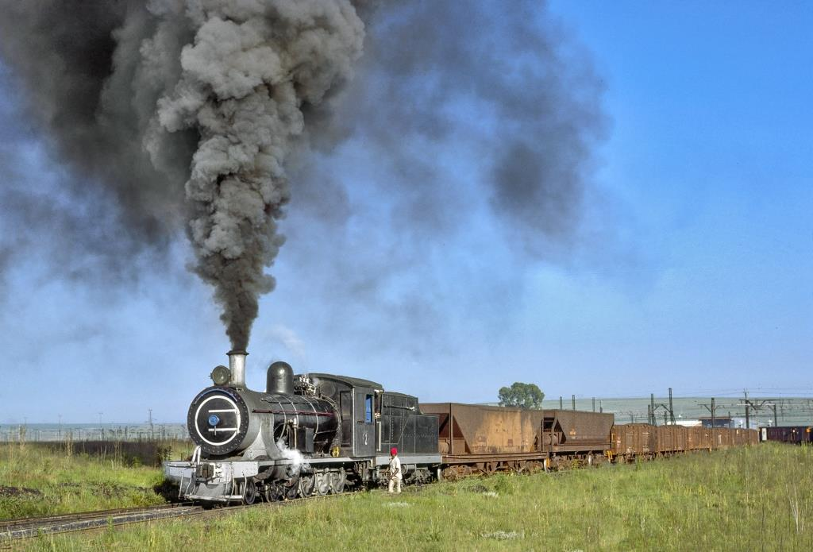

In the superb photo above, WCC No 2 hauls a loaded coal train away from the mine. No 2 was formerly SAR 7C Class 4-8-0 No 1059 and was built by Neilson Reid in 1902 (works no 6079). It was acquired 3rd hand from SAR then Hawerklip Colliery and lasted at Witbank until the mid 1980’s.

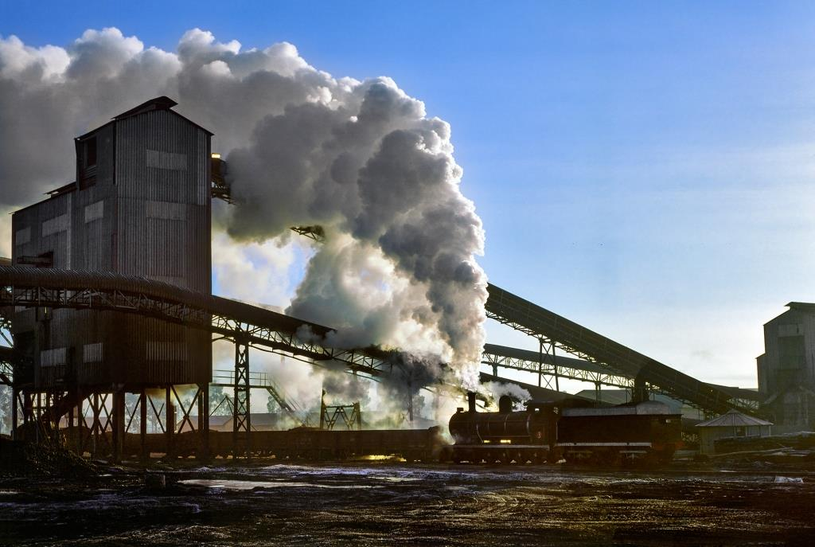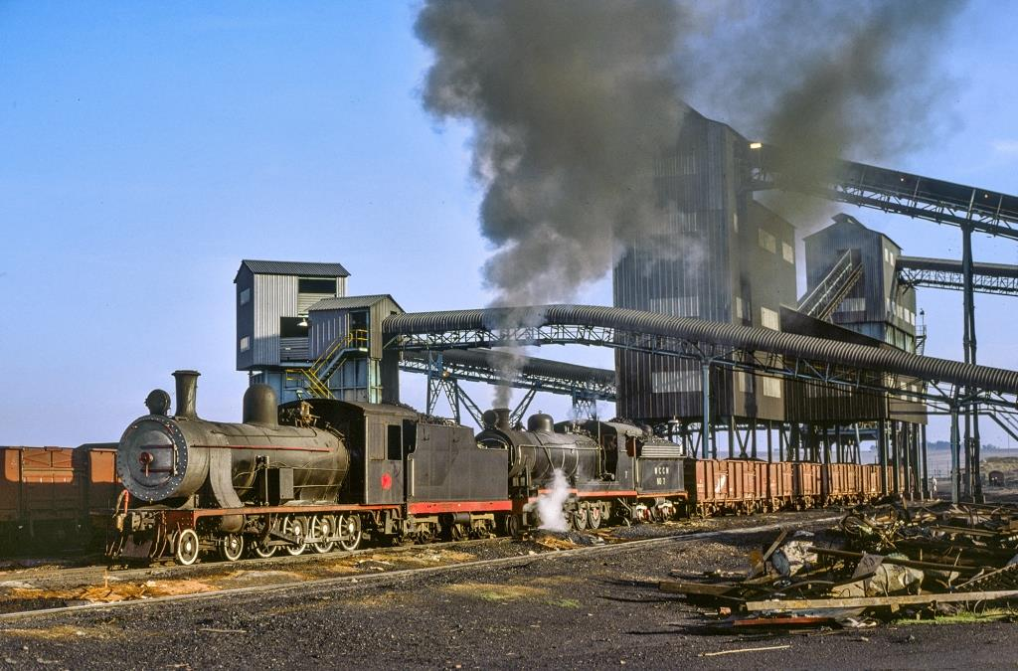

Richard’s next photo shows WCC No 3 shunting at the mine in July 1979. This venerable old loco started life at Sharp Stewart in Glasgow in 1896 (works no 4147) and became SAR No 990 before moving to the mine. Finally we see a fascinating double header with No 2 teamed up with 4-8-0 No 7. No 7 was originally a standard North British 4-8-2 tank loco (NB 26244) and was rebuilt as a tender engine at Tweefontein Colliery.
We are indebted to Richard for these amazing photos of a bygone era.
(4)
NZ HISTORY (photos : JM Creber)
Our New Zealand correspondent Wilson Lythgoe has kindly sent two vastly different views of the last-built Ja Class 4-8-2 No 1290 (NB 27119) this month, as seen through the lens of Ace Cameraman Jack Creber.

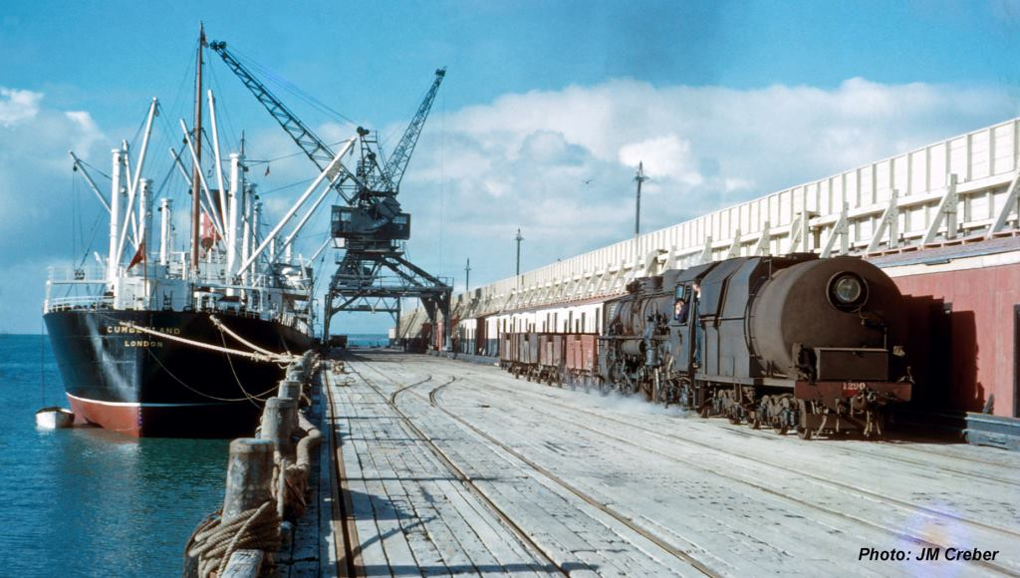
On Wednesday 26th June 1957 Jack took this evocative picture of the last-built Ja No 1290 (NB 27119) shunting on a wharf at New Plymouth Port. The ship featured appears to be the Cumberland of London but little else about it is known. This was taken back in the happy days when anyone could wander onto the wharves for a little photography or to do a spot of fishing but sadly this is no longer the case !

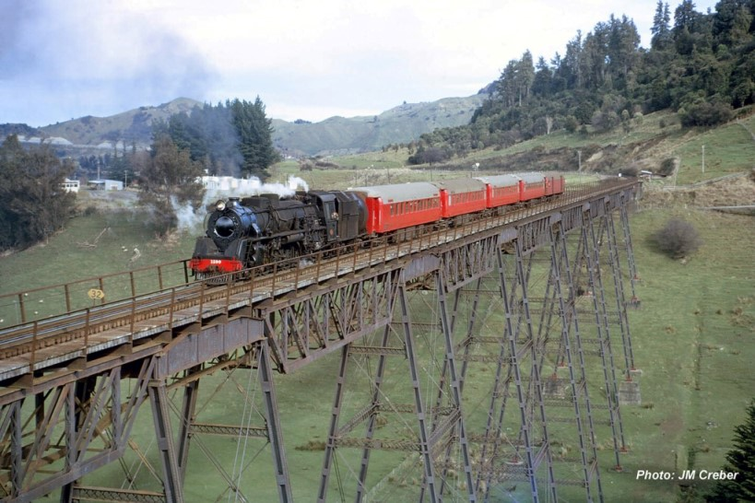
Eight years later, on 24th July 1965, Jack found the same locomotive crossing Mangaweka Viaduct with a NZRLS Excursion bound for Waiouru. This scene is reminiscent of the trestle viaducts on the Stainmore Line in the UK. Ja 1290 was the last steam locomotive to be built for New Zealand Railways and some of the Class lasted until the end of NZR steam in October 1971. Seven of the class have been preserved.
(5)
NEWS IN BRIEF (photo courtesy Tony Marsden)

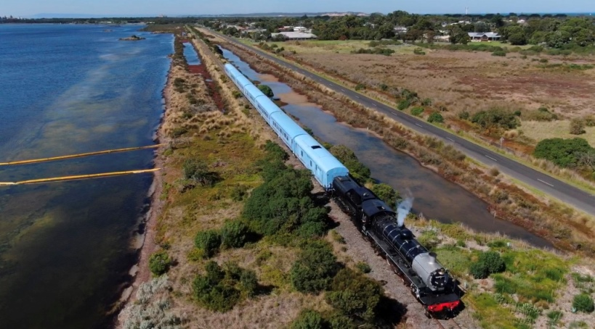

As promised a while back, here is one of Tony Marsden’s stunning Drone’s Eye views of Australia’s immaculate ‘Q’ train with North British Class 24 2-8-4 3620 (NB 26332) at its head en route from Queenscliff to Drysdale on 14th May 2021. Apologies by the way for wrongly crediting last month’s photo of Michael Barclay on 3620 to Tony. We will credit it correctly if we can ascertain the name of the photographer.
The preserved North British Standard Industrial 4-8-2 Tank locomotive at Loraine Gold Mines (NB 27090) was removed from its’ plinth near the old Mine Clubhouse in Allanridge by crane on 9th August. Local sources believe that it is being taken to the Harmony Gold Mines workshop in Welkom for restoration. We did attempt to purchase this loco some years back when it was starting to deteriorate but Harmony told us that it was being retained as it was part of the heritage of the mine. Any further news on this locomotive would be appreciated.
The Mpumalanga Rail Company report that a new contractor has been found to take over the overhaul of 19D No 2767. Also that they are continuing to work on Middelburg Station and are waiting for a Transnet Access Agreement so they can run on the line to Dullstroom. Once security has been improved at Middelburg the 1A 4-8-0 from Greenside Colliery, which has been donated on loan to NBLPG, will be placed on display.
It has been announced that LNER design B1 No 61306 (NB 26207) will run a series of specials based on Colchester and Ipswich in August carrying a B17 style number ‘61674’ and the name ‘Ipswich Town’. North British did of course play a key role in designing and building the original B17’s. Full details of these, and many other, forthcoming tours can be found on the Steam Dreams website : https://www.steamdreams.co.uk
If you would like to comment on any of the items in this Newsletter or discuss any of the issues raised above please email ken.livermore@btinternet.com or phone me on 07990 575 103. Photos and news items for future Newsletters are always needed and can be emailed to me or posted on our Facebook page at : https://www.facebook.com/NorthBritishLocomotives

Thank you all once again for your continued support, stay safe out there !
More news to follow next month, Best Regards, Ken

Newsletter published by the NBL Preservation Group - A Not for Profit Organisation

