NBL Preservation Group

Honorary President Professor Dugald Cameron OBE

September 2021 Newsletter

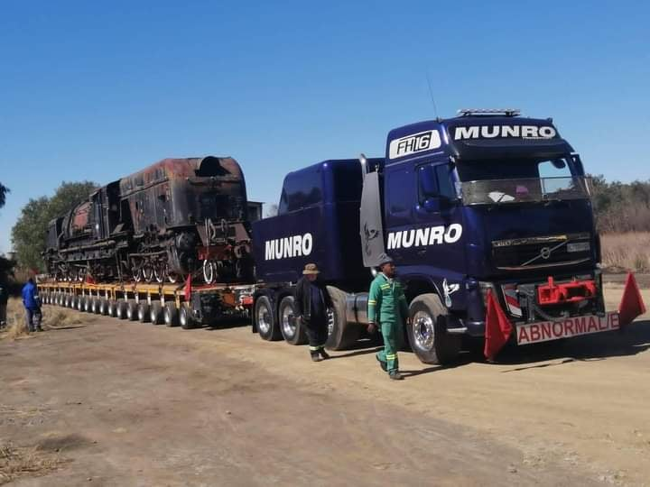

SANDSTONE GMAM MOVES (photo Andre Guelpa)

Exciting news this month is that the Sandstone Heritage Trust have started to move some of their Cape Gauge steam locomotive collection to the Sandstone Estates at Ficksburg. The first locomotive to move was North British GMAM Garratt No 4114 on 19th August and a full report can be found on Page 2 of this Newsletter. There are more locomotives to follow from Bloemfontein and it should not be forgotten that Sandstone also have engines at Germiston, including a North British 15F and a 25NC and it will be very interesting to see what the future holds for them.

In the meantime, Andre Guelpa’s superb photo above shows No 4114, still in one piece, successfully loaded onto a mammoth trailer ready for the 120 miles journey to her new home.

(2)

SANDSTONE LOCO MOVES (Contd) Notes & photos courtesy Sandstone Heritage Trust

Dave Richardson of the Sandstone Heritage Trust has kindly sent us an update on a number of steam locomotive moves that are currently taking place in South Africa. As several of Sandstone’s locos were built by North British I have included Dave’s notes in full. Dave will take up the story from here :

As Sandstone is not actively involved with 3’6” gauge operations it has been decided to move our 3’6” assets off Transnet property at the old Bloemfontein steam loco depot and relocate them to Sandstone Estates at Ficksburg. The first locomotive to be moved is the rather forgotten “other” GMAM, number 4114 (NB 27772). This locomotive was purchased from Randfontein Estates Gold Mine at the same time as Beyer Peacock GMAM number 4079 “Lyndie Lou” which saw a great deal of main line use up to a few years ago.

4114 had been cared for by Lukas Nel before he retired in April 2019 and was moved on August 19, 2021, from its parking space next to the old loco shed in Bloemfontein Depot for loading on road transport to Ficksburg. It is believed that this is the largest locomotive ever moved by road in South Africa and unusually the GMAM has not been split into its component parts. Some clever logistics by Mercor Transport and Munro Transport has enabled the loco to be placed on a massive multi axle trailer in one piece. Avoiding the use of heavy and expensive cranes was key and by utilising a second gooseneck lowbed trailer as a loading ramp, 4114 was safely loaded on to the multi axle trailer without damage to any of the pivots which is always a risk when moving Garratt locos. 4114 weighs 160 tons devoid of coal and water and is just under 29 metres long.

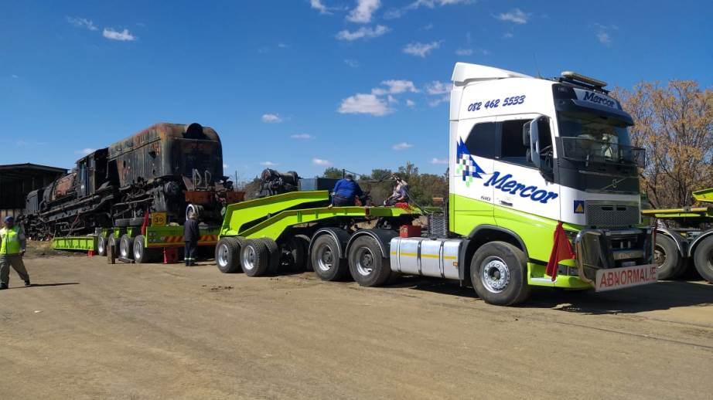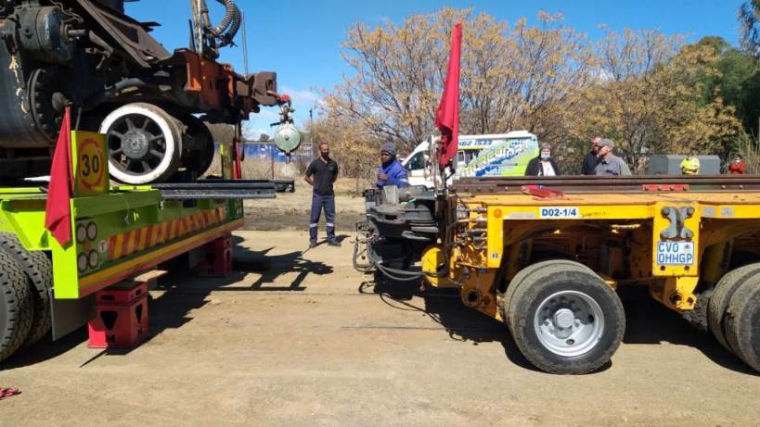

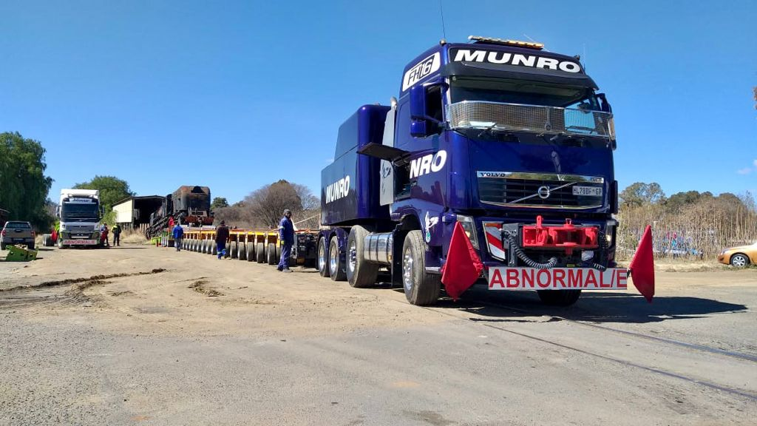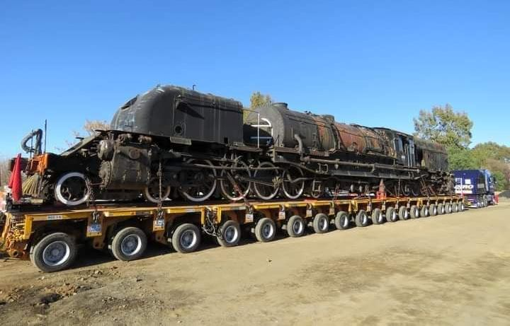

There are other locomotives to be moved from Bloemfontein over the next few weeks and we will update the web site as this happens. Already there are some wonderful stories emerging about these later moves as some railway lines seem to have disappeared leaving the assets trapped. However, work is ongoing with a road construction gang to build a “highway” to their parking spot so they can be safely loaded. We must also say thank you to Transnet for their excellent cooperation and assistance at Bloemfontein Depot and at Transnet Head Office in Johannesburg for making the operation totally straightforward.

Many thanks to Dave for sending us the story of this amazing move. We will bring you more photos of the various loco moves as they become available. In the meantime details of this and other exciting events can be found on the Sandstone website at : https://www.sandstone-estates.com
(3)
BLYTH PROGRESS (photos : North Bay Engineering)
We are very grateful to North Bay Engineering Services for supplying these photos of the construction of replica Southwold Railway Sharp Stewart 1879 2-4-0T ‘Blyth’ at their workshops in Darlington. In May the first of the side tanks were fitted, August saw the reverser in place and now the cab is being painted !

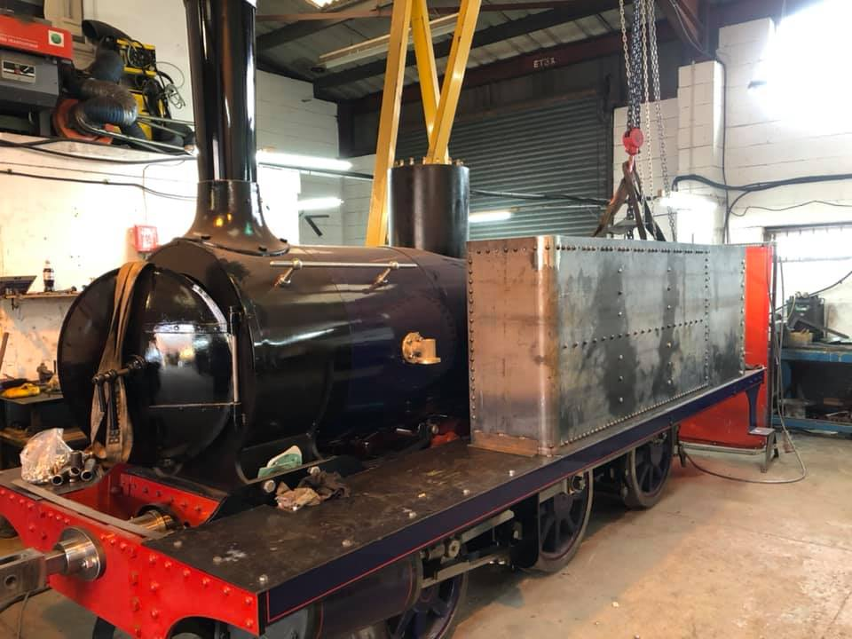
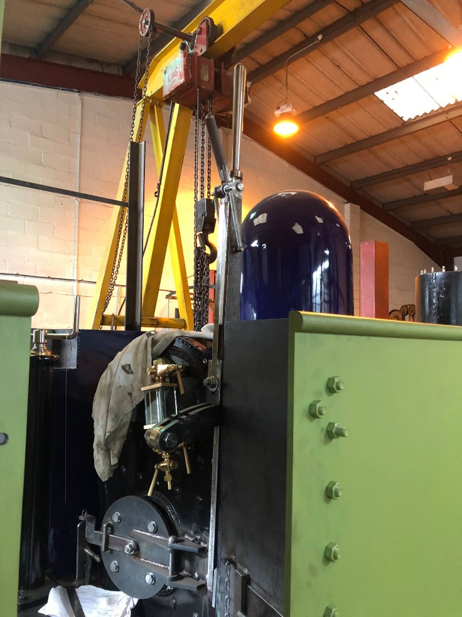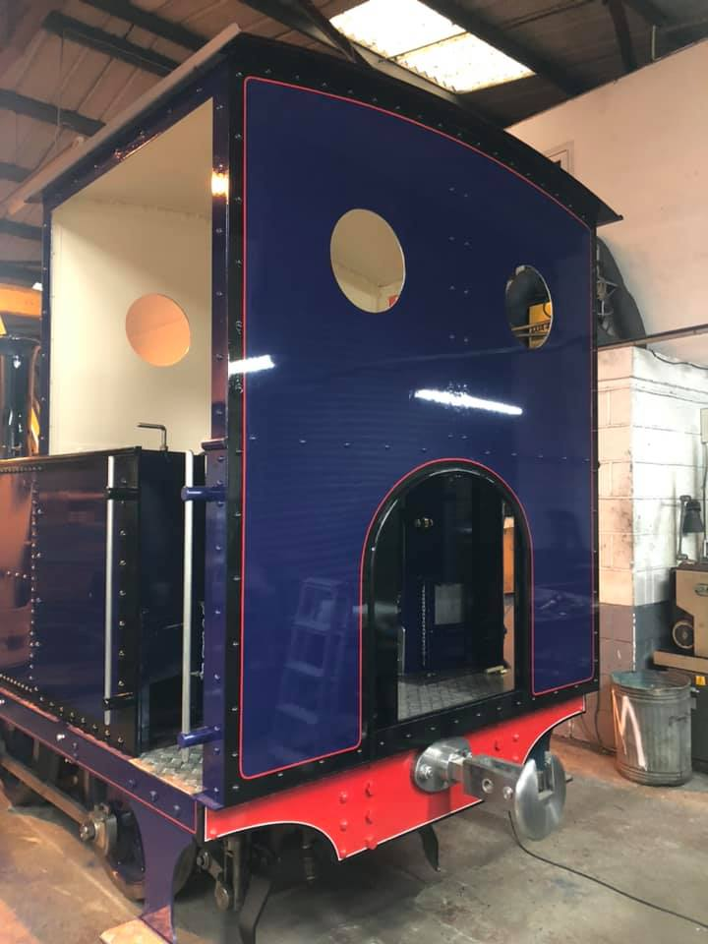
We look forward to seeing this beautiful little loco in steam ! More details and photos can be found on : https://www.southwoldrailway.co.uk/trust-projects/2-4-0t-no-3-blyth
(4)
R766 REVIVAL (photos : Tony Marsden)

The news that Victorian Railways 4-6-4 No R766 (NB 27056) is about to commence running trials in New South Wales prompted Tony Marsden to send us some photos of the loco that he took at Newport Workshops back in December 2007 when it was being re-gauged from the VR 5ft 3ins Broad Gauge to NSW Standard Gauge. R766 was built to be gauge convertible and was the first steam loco in Australia to have this work actually carried out.

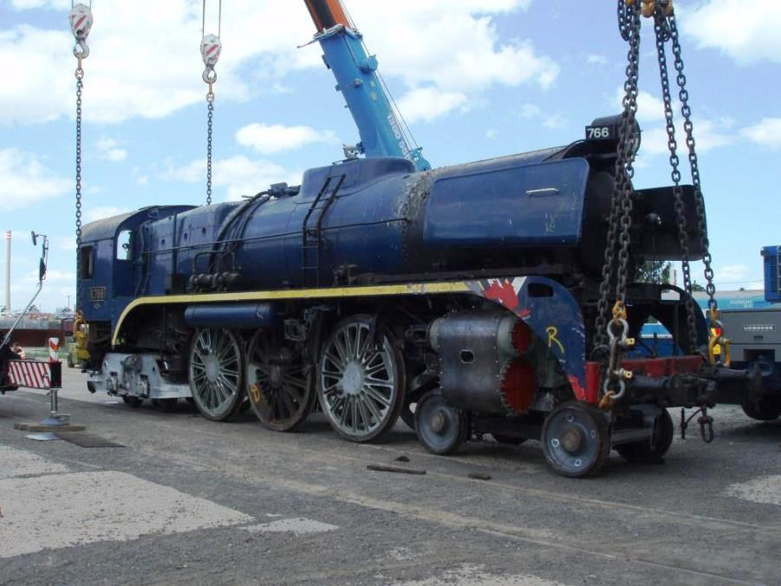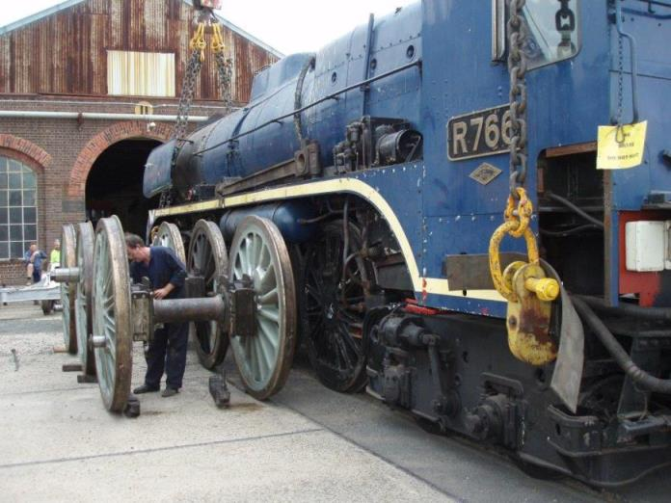
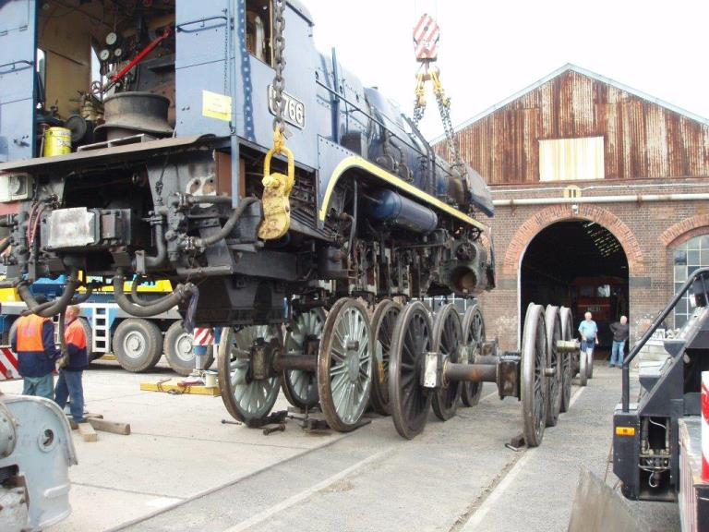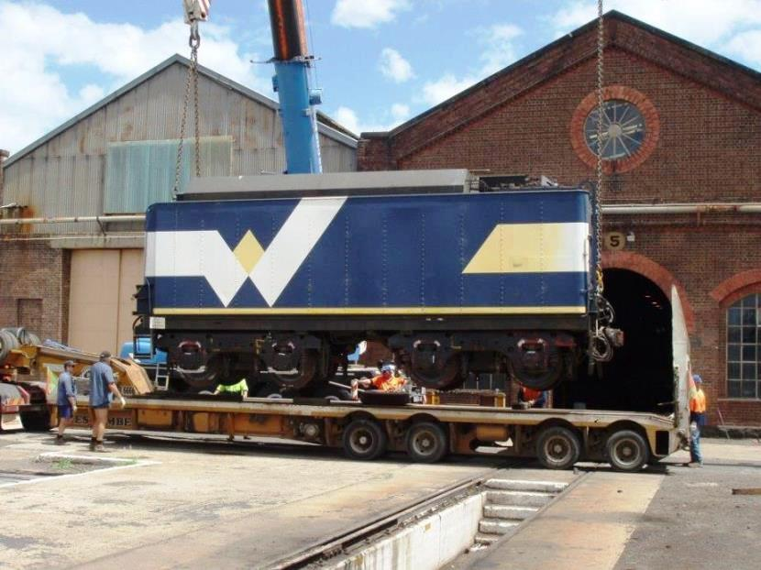

R 766 has passed through a number of operators and owners in preservation. It was acquired by a company trading as "Australian Vintage Travel" in 1981 and restored to operating condition for hauling luxury rail services. After Australian Vintage Travel folded in 1986, R 766 was acquired by a syndicate of shareholders and leased to Steamrail Victoria.

Steamrail volunteers re-painted R 766 in maroon livery before the locomotive was leased to West Coast Railway and repainted in the WCR corporate blue livery in 2000. Following its withdrawal from West Coast Railway service, R 766 was converted from 5 ft 3 in (1,600 mm) to 4 ft 8+¹⁄₂ in (1,435 mm) standard gauge by the Hunter Valley Railway Trust and was transferred North Rothbury in New South Wales on the site of the former Rothbury Colliery, in December 2007.

An ICE radio, to enable the loco to work on the main line, was fitted in 2019 and limited trials commenced in 2020. These were disrupted by the lockdown but it is hoped that the trials will resume again soon. An on-line posting the at the end of July announced that the loco has been repainted in Victorian Railways Red and Black livery and is now set to start being tested on the standard gauge mainlines. We look forward to this with great interest, more details can be found on : https://huntervalleyrailway.tripod.com
(5)
NEWS IN BRIEF (photo : Robin Coombes)
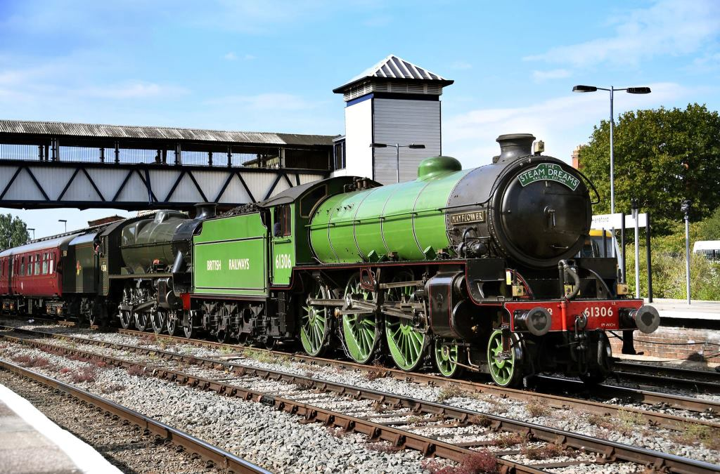

A rare North British double header occurred on 8th September 2021 when LNER B1 No 61306 ‘Mayflower’ (NB 26207) teamed up with LMS Jubilee No 45596 ‘Bahamas’ (NB 24154) to haul the final leg of the Steam Dreams ‘Welsh Dragon’ excursion running between Holyhead and London Paddington. The two 4-6-0’s took over the train at Crewe and made a great circuit to London via Shrewsbury, Hereford, Severn Tunnel Junction, Gloucester and Swindon. Robin took this fine photo of the two NBL 4-6-0’s during a pause at Hereford.
After 10 years on site, an Agreement has been signed with the Woking Miniature Railway Society regarding the display of our Natal Government Railways Dubs Tank No 196 at the Mizens Railway. There are no shocks or surprises in the document which simply puts in writing what was originally agreed back in 2011 with the then Mizens Committee. A plaque is to be fitted to the loco stating its origin and ownership.
For the first time in eighteen months, services resumed over the whole distance of the Darjeeling Himalayan Railway on August 25th using NBL and Sharp Stewart steam locos interspersed with diesels. The timetable remains the same as existed when services were summarily withdrawn due to the lockdown in March last year, with daily departures from New Jalpaiguri at 1000 and from Darjeeling at 0800. Each train consists of one first class saloon, one ‘vistadome’ coach and a van. Details on the DHRS website at : https://www.dhrs.org
If you would like to comment on any of the items in this Newsletter or discuss any of the issues raised above please email ken.livermore@btinternet.com or phone me on 07990 575 103. Photos and news items for future Newsletters are always needed and can be emailed to me or posted on our Facebook page at : https://www.facebook.com/NorthBritishLocomotives

Thank you all once again for your continued support, stay safe out there !
More news to follow next month, Best Regards, Ken

Newsletter published by the NBL Preservation Group - A Not for Profit Organisation

