The NBL Preservation Group

Would Like To Wish Everyone

A Merry Christmas !

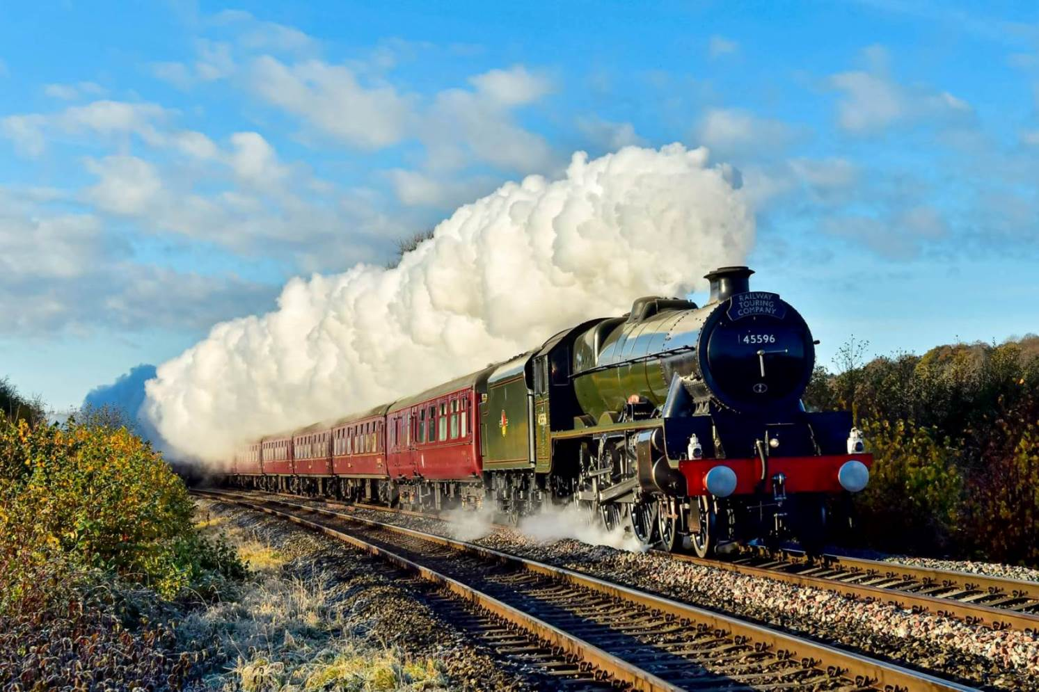

45596 Bahamas near Pontrilas (photo from Kall Chels Buckley Evans)

We have a slight departure from our usual snowy Christmas scene this month as I felt that this wonderful photograph by Kall was perfect for our front page ! It shows Double Chimney ‘Jubilee’ No 45596 ‘Bahamas’ (NB 24154) on the ‘Christmas Cheshireman’ near Pontrilas on Saturday 19th November. The tour ran from Bristol Temple Meads to Chester via Cwymbran and Abergavenney with the return run being handled by LMS ‘Coronation’ No 46233 ‘Duchess of Sutherland’. Perfect loco, perfect lighting, perfect composition – what more could we want ! Thanks again to Kall for letting us use your brilliant photograph.

As the end of 2022 approaches, I would like to thank our Members and Friends for staying with us through these difficult times. I’d like to send a special thanks to all those who contributed photographs and news items for our Newsletter. During the year we have received historical notes and news items about North British locomotives from all over the World and they are greatly appreciated. Please keep them coming !

(2)
NBL MALLETS II (photos John Carter)

Following on from our brief feature on the NBL Mallets in last month’s Newsletter, John Carter from the Continental Railway Circle has very kindly allowed us to use two of his wonderful photos of Sierra Menera NBL Mallet No 401 ‘Jerica’ (NB 19321) which he took in 1964 and 1966 respectively.

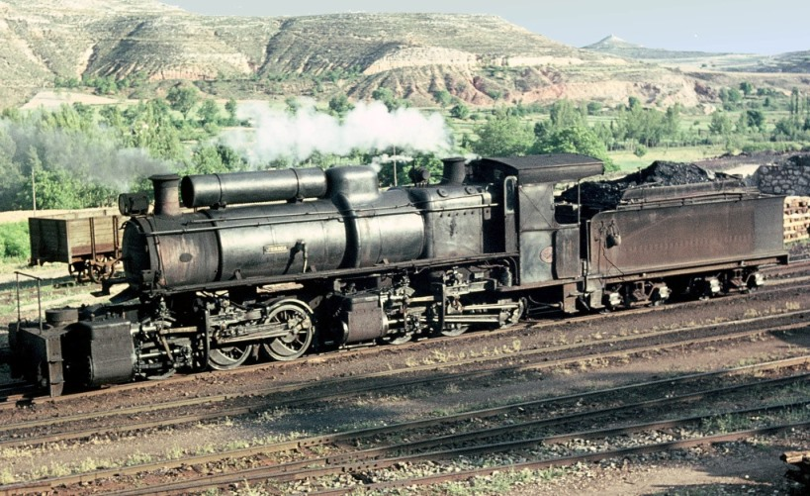

John says his first sight of No 401 was at the depot at Puerto de Escandon (above) where the Mallet posed in the Spanish sunshine. His next sighting of the same engine was working a loaded train on the Sierra Menera system (below). John recalls that the train was so heavy that it needed to be banked by a Garratt !

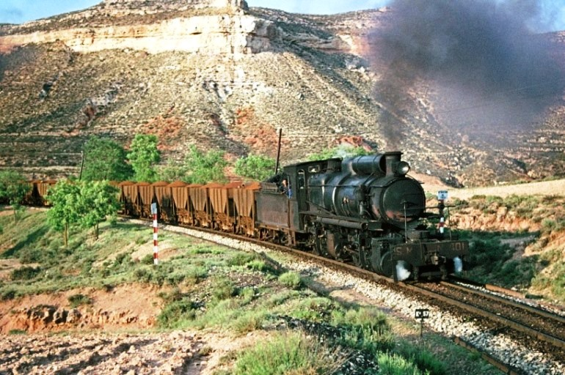

Thanks again John for these amazing photographs.
(3)
3BR RESTORATION (Photos courtesy Umgeni Steam Railway)

A small team of volunteers on the Umgeni Steam Railway are currently hard at work restoring North British 3BR 4-8-2 No 1486 (NB 19690) at their Inchanga depot near Durban. This will be the engine’s 2nd full overhaul since it was retired from service at Umgala Colliery in the 1990’s and funds are urgently required to enable the work to be completed. The engine is now in its’ 110th year so as can be appreciated, the overhaul is very extensive with many parts needing to be refurbished or made new.

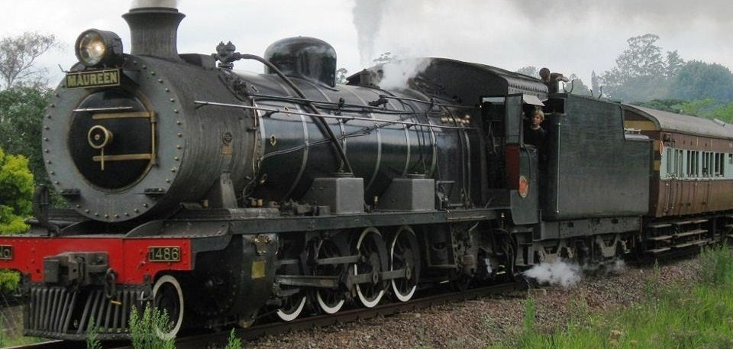
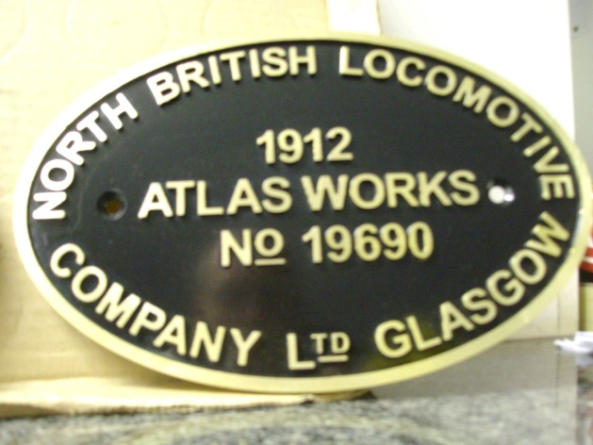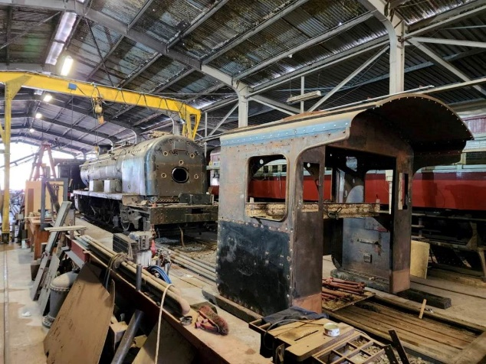
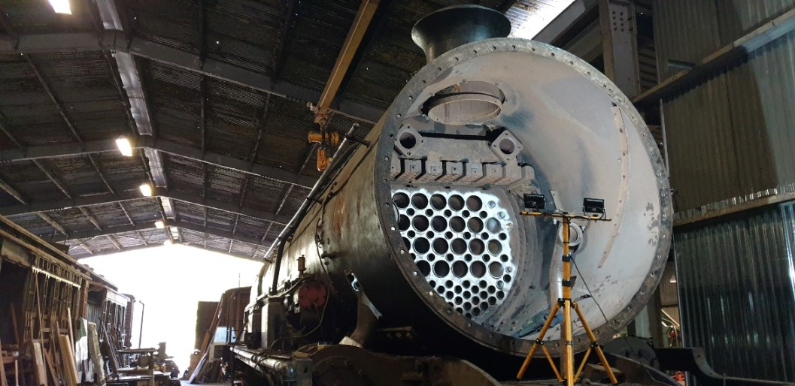

If momentum can be maintained it is hoped to steam No 1486 next year. Full details of how you can help the USR team to complete the restoration work and bring this historic old engine back to life can be found on their Facebook page at : https://www.facebook.com/groups/USR3BR or on http://umgenisteamrailway.com/
(4)
NZR HISTORY (Photos JM Creber)

Two more glorious photos from the camera of Jack Creber this month, courtesy of our old friend Wilson Lythgoe and the Trevor Cheer Collection. Although they are vastly different photographs, both were taken in the Kopuawhara area on 12th November 1965 and both feature Ja Class 4-8-2 No 1290 (NB 27119).

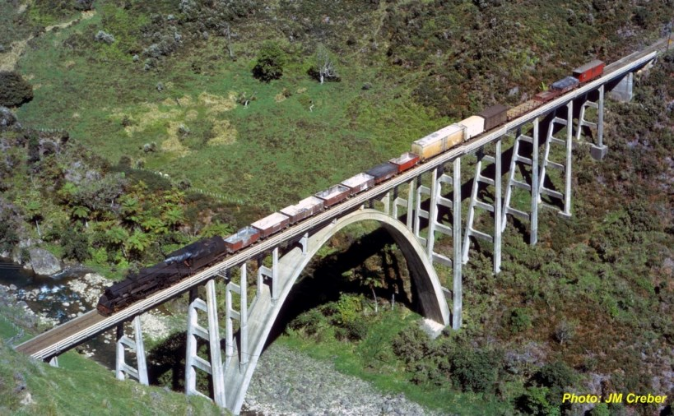

Firstly, we see No 1290 crossing the impressive Kopuawhara Viaduct. This was completed in 1942 and was originally known as the Waiau Stream Viaduct. It is one of six viaducts on the Napier to Gisborne Railway.

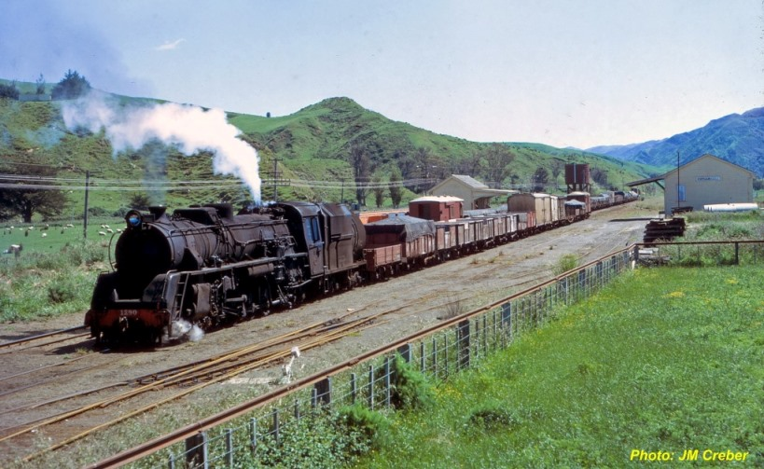

Later we see the same train in Kopuawhara Station ready for the return run to Gisborne. Jack’s photo shows the very rural nature of this part of New Zealand’s North Island. (Many thanks to Wilson for these pictures)
(5)
NEWS IN BRIEF (photo Peter Rogers)

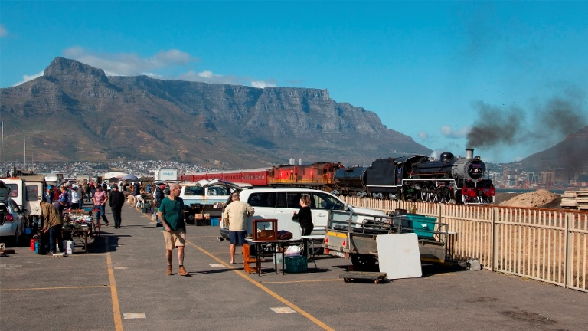

A far cry from the freezing cold UK weather, South African 19D No 3322 (NB 26042) passes Milnerton Market with its’ glorious backdrop of Table Mountain on its’ way out of Cape Town on 26th November 2022. Ceres Rail are to be applauded on keeping steam alive on their regular excursions to Elgin and full details can be found on their website : https://www.ceresrail.co.za We also thank Peter for his wonderful photograph reminding us all of what we are missing !

LNER K1 2-6-0 No 62005 (NB 26609) was withdrawn from duties on the ‘Jacobite’ earlier this year due to worn driving wheel tyres. The loco was taken to Carnforth depot for overhaul as the boiler ticket expired soon after. Since then the boiler has been lifted and work has started on overhauling the bottom end of the engine. The work is being carried out jointly between the owning group The North Eastern Locomotive Preservation Group and the West Coast Railway Company who are the operators of the ‘Jacobite’. Further details of the overhaul and how you can help are available on the NELPG website : www.nelpg.org.uk

The Basque Railway Museum, who’s fleet includes Sharp Stewart 0-6-0T ‘Zugastieta’ (SS 3435 of 1888) will be operating a series of steam trains on the run up to Christmas. Full details can be found on the BML Amigos del Museo Vasco del Ferrocarril facebook page at : https://www.facebook.com/BML.azpeitia

If you would like to comment on any of the items in this Newsletter or discuss anything related to North British Locomotives, please email ken.livermore@btinternet.com or phone me on 07990 575 103. Photos and news items for future Newsletters can be emailed to me or posted directly onto our NBL Facebook page at : https://www.facebook.com/NorthBritishLocomotives

Thank you all once again for your continued support, have a great Christmas !

More News Next Month, Best Regards, Ken

Newsletter published by the NBL Preservation Group, A Not for Profit Organisation

